LECTURE 5: A VERY SHORT INTRODUCTION TO READING THE QUR’AN

1 European Readers of the Qur’an

- Whether or not to translate is theological point

- First Latin translation in 1143 by Robert of Ketton

- First translated into English in 1734 by George Sale

- Thomas Carlyle said of Qur’an “it is as toilsome reading as I ever undertook. A wearisome confused jumble, crude, incondite; endless iterations, long-windedness, entanglement…Nothing but a sense of duty could carry any European through the Koran.”

- New investigations in mid-19thC with Theodor Nӧldeke: construct the Qur’an chronologically

- Suggested chronology: Ernst (p39ff) & Comparative Index to Islam : QUR'AN (answering-islam.org):
Surah No. | Surah Name | English Name | No. of Verses | Place | Chronological Order
1 | Al-Fatihah | The Opening | 7 | Mecca | 5
2 | Al-Baqarah | The Cow | 286 | Madina | 87
3 | Âl 'Imran | The Family of 'Imran | 200 | Madina | 89
4 | An-Nisa' | Women | 176 | Madina | 92
5 | Al-Ma'idah | The Table | 120 | Madina | 112
6 | Al-An`am | The Cattle | 165 | Mecca | 55
7 | Al-A`raf | The Elevated Places | 206 | Mecca | 39
8 | Al-Anfal | The Spoils of War | 75 | Madina | 88
9 | At-Taubah | Repentance | 129 | Madina | 113
10 | Yunus | Jonah | 109 | Mecca | 51
11 | Hud | Hud | 123 | Mecca | 52
12 | Yusuf | Joseph | 111 | Mecca | 53
13 | Al-Ra`d | The Thunder | 43 | Madina | 96
14 | Ibrahim | Abraham | 52 | Mecca | 72
15 | Al-Hijr | The Rock | 99 | Mecca | 54
16 | An-Nahl | The Bee | 128 | Mecca | 70
17 | Bani Isra'il | The Israelites | 111 | Mecca | 50
18 | Al-Kahf | The Cave | 110 | Mecca | 69
19 | Maryam | Mary | 98 | Mecca | 44
20 | Ta Ha | Ta Ha | 135 | Mecca | 45
21 | Al-Anbiya' | The Prophets | 112 | Mecca | 73
22 | Al-Hajj | The Pilgrimage | 78 | Madina | 103
23 | Al-Mu'minun | The Believers | 118 | Mecca | 74
24 | An-Nur | The Light | 64 | Madina | 102
25 | Al-Furqan | The Criterion | 77 | Mecca | 42
26 | Ash-Shu`ara' | The Poets | 227 | Mecca | 47
27 | An-Naml | The Ant | 93 | Mecca | 48
28 | Al-Qasas | The Narrative | 88 | Mecca | 49
29 | Al-`Ankabut | The Spider | 69 | Mecca | 85
30 | Ar-Rum | The Romans | 60 | Mecca | 84
31 | Luqman | Lukman | 34 | Mecca | 57
32 | As-Sajdah | The Adoration | 30 | Mecca | 75
33 | Al-Ahzab | The Allies | 73 | Madina | 90
34 | Saba' | Sheba | 54 | Mecca | 58
35 | Fatir | The Creator | 45 | Mecca | 43
36 | Ya Sin | Ya Sin | 83 | Mecca | 41
37 | As-Saffat | The Rangers | 182 | Mecca | 56
38 | Sad | Sad | 88 | Mecca | 38
39 | Az-Zumar | The Companies | 75 | Mecca | 59
40 | Al-Mu'min | The Forgiving One | 85 | Mecca | 60
41 | Ha Mim | Ha Mim | 54 | Mecca | 61
42 | Ash-Shura | The Counsel | 53 | Mecca | 62
43 | Az-Zukhruf | The Embellishment | 89 | Mecca | 63
44 | Ad-Dukhan | The Evident Smoke | 59 | Mecca | 64
45 | Al-Jathiyah | The Kneeling | 37 | Mecca | 65
46 | Al-Ahgaf | The Sandhills | 35 | Mecca | 66
47 | Muhammad | Muhammad | 38 | Madina | 95
48 | Al-Fath | The Victory | 29 | Madina | 111
49 | Al-Hujurat | The Chambers | 18 | Madina | 106
50 | Qaf | Qaf | 45 | Mecca | 34
51 | Adh-Dhariyat | The Scatterers | 60 | Mecca | 67
52 | At-Tur | The Mountain | 49 | Mecca | 76
53 | An-Najm | The Star | 62 | Mecca | 23
54 | Al-Qamr | The Moon | 55 | Mecca | 37
55 | Ar-Rahman | The Merciful | 78 | Madina | 97
56 | Al-Waqi`ah | That Which is Coming | 96 | Mecca | 46
57 | Al-Hadid | The Iron | 29 | Madina | 94
58 | Al-Mujadilah | She Who Pleaded | 22 | Madina | 105
59 | Al-Hashr | The Exile | 24 | Madina | 101
60 | Al-Mumtahanah | She Who is Tested | 13 | Madina | 91
61 | As-Saff | The Ranks | 14 | Madina | 109
62 | Al-Jum`ah | The Day of Congregation | 11 | Madina | 110
63 | Al-Munafiqun | The Hypocrites | 11 | Madina | 104
64 | At-Taghabun | The Cheating | 18 | Madina | 108
65 | At-Talaq | The Divorce | 12 | Madina | 99
66 | At-Tahrim | The Prohibition | 12 | Madina | 107
67 | Al-Mulk | The Kingdom | 30 | Mecca | 77
68 | Al-Qalam | The Pen | 52 | Mecca | 2
69 | Al-Haqqah | The Inevitable | 52 | Mecca | 78
70 | Al-Ma`arij | The Ladders | 44 | Mecca | 79
71 | Nuh | Noah | 28 | Mecca | 71
72 | Al-Jinn | The Jinn | 28 | Mecca | 40
73 | Al-Muzammil | The Mantled One | 20 | Mecca | 3
74 | Al-Mudathir | The Clothed One | 56 | Mecca | 4
75 | Al-Qiyamah | The Resurrection | 40 | Mecca | 31
76 | Ad-Dahr | The Time | 31 | Madina | 98
77 | Al-Mursalat | The Emissaries | 50 | Mecca | 33
78 | An-Naba' | The Tidings | 40 | Mecca | 80
79 | An-Naziat | Those Who Pulled Out | 46 | Mecca | 81
80 | `Abasa | He Frowned | 42 | Mecca | 24
81 | At-Takwir | The Cessation | 29 | Mecca | 7
82 | Al-Infitar | The Cleaving Asunder | 19 | Mecca | 82
83 | At-Tatfif | The Defrauders | 36 | Mecca | 86
84 | Al-Inshiqaq | The Rending | 25 | Mecca | 83
85 | Al-Buruj | The Constellations | 22 | Mecca | 27
86 | At-Tariq | The Night-Comer | 17 | Mecca | 36
87 | Al-A`la | The Most High | 19 | Mecca | 8
88 | Al-Ghashiyah | The Overwhelming Calamity | 26 | Mecca | 68
89 | Al-Fajr | The Dawn | 30 | Mecca | 10
90 | Al-Balad | The City | 20 | Mecca | 35
91 | Ash-Shams | The Sun | 15 | Mecca | 26
92 | Al-Layl | The Night | 21 | Mecca | 9
93 | Ad-Duha | The Early Hours | 11 | Mecca | 11
94 | Al-Inshirah | The Expansion | 8 | Mecca | 12
95 | At-Tin | The Fig | 8 | Mecca | 28
96 | Al-`Alaq | The Clot | 19 | Mecca | 1
97 | Al-Qadr | The Majesty | 5 | Mecca | 25
98 | Al-Bayyinah | The Proof | 8 | Madina | 100
99 | Al-Zilzal | The Shaking | 8 | Madina | 93
100 | Al-`Adiyat | The Assaulters | 11 | Mecca | 14
101 | Al-Qari`ah | The Terrible Calamity | 11 | Mecca | 30
102 | At-Takathur | Worldly Gain | 8 | Mecca | 16
103 | Al-`Asr | Time | 3 | Mecca | 13
104 | Al-Humazah | The Slanderer | 9 | Mecca | 32
105 | Al-Fil | The Elephant | 5 | Mecca | 19
106 | Al-Quraysh | The Quraish | 4 | Mecca | 29
107 | Al-Ma'un | The Daily Necessaries | 7 | Mecca | 17
108 | Al-Kauthar | Abundance | 3 | Mecca | 15
109 | Al-Kafirun | The Unbelievers | 6 | Mecca | 18
110 | An-Nasr | The Help | 3 | Madina | 114
111 | Al-Lahab | The Flame | 5 | Mecca | 6
112 | Al-Ikhlas | Purity (of Faith) | 4 | Mecca | 22
113 | Al-Falaq | The Daybreak | 5 | Mecca | 20
114 | An-Nas | Mankind | 6 | Mecca | 21

- Early commentators suggest different chronologies

  - See also Islam Dayeh “Al-Haswamim: Intertextuality and Coherence in Meccan Surahs, in Angelika Neuwirth et al The Qur’an in Context, pp461-498 and James White How to read the Qur’an pp52-53

2 Literary and Historical Readings of Surah 18 The Cave

- What did you think of surahs 3, 18 and 19?

- Qur’an usually read thematically/systematically, but can be read as whole surahs – can you discern a structure to the surah 18? What are its themes?

2a) A Literary Reading (based on Ernst)
- Surah 18 “most mythical” section of Qur’an

- Has “ring composition”:

1-2 book without crookedness 109 ink = book image

2 warning to unbelievers 102-6 warning to unbelievers

2-3 promise of paradise to faithful 107-8 paradise promised to faithful

4-5 rejects incarnation 110 Md only a man inspired by God

5 deceitful ancestral tradition 109 limitless words of God’s revelation

6 consolation to rejected-messenger 110 assurance that he is inspired

8 sign of earth’s beauty is a test 105 sign as object of disbelief

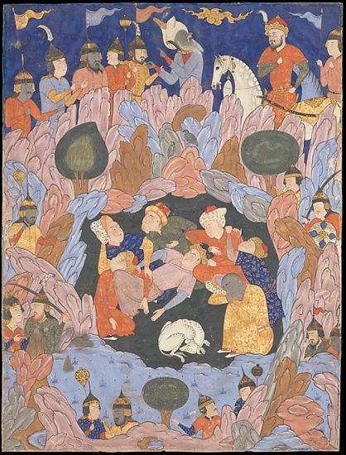
- 9-31 (24 verses) The sleepers:

- Rip van Winkel?

- 7 Sleepers of Ephesus from Jacob Sarug (450-521) about believers in reign of Decius (249-51)

- 32-59 Parables and Debate (28 verses)

By kind permission of www.metmuseum.org
- 60-82 Story of Moses and al-Khidr (24 verses)

  - Al-Khidr / The Green One is a mysterious, deathless prophet who teaches Moses.
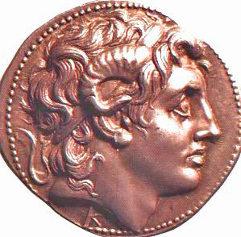

  - Sufis use this story to show need for mystical experience

- 83-101 The Horned-One (Dhul al Qarnain) 20 verses

  - 2 horns of ram = Ammon = Zeus = Alexander the Great
  - Alexander as archetypal world ruler

  - Supports morality and fact of judgement(!)

- Ernst: indicates breadth of appropriation of previous stories (cf Lecture 4 Handout)

- Commentator Muhammad Asad: aya 7 as key for surah “we have willed all beauty on earth be a means by which we put man to a test”

- 7 Sleepers abandoned all for their faith

- Moses and the sage show importance of intellect and truth-seeking

- Horned-One shows world power and wealth is not in conflict with righteousness

2b) A Historical Reading
- Helpful literary analysis, but what about historical analysis?

- In Mecca, at time of opposition, maybe 5th year of Muhammad’s mission

  - “Ask Muhammad: Who were sleepers in the cave? Who was the mighty king who reached the confines of both East and West? What is the Spirit?”

  - Muhammad promised to answer their questions tomorrow

    - cf aya23-24 and possible presumption on Muhammad’s part

  - Took 15 days to answer, and the question of the Spirit remained unanswered

3 Reading about Mary the Mother of Jesus (and Sister of Aaron?)

- Have done some literary criticism and some historical criticism, now for some source criticism

- Qur’an uses the Bible eg s7:54 re 6 day creation, but seems to get some things wrong

- Who are surahs 3:33-64 and 19:1-40 about?

- What is similar/different to the Bible’s account? How does Ezekiel 43 shed some light here?

- Individual stories of Mary and Zechariah in s19, become merged in s3

  - ?like in Luke 1-2?

  - And, Mary’s mother vow for baby to end up in Temple s3:35 is like…(and apocryphal Gospel of James/Infancy Gospel of James/Protoevangelium of James, c. AD145)

- Seems odd, but not necessarily a Qur’anic invention:

  - S19:23-26 the birth of Jesus and the miraculous river is found in Pseudo Gospel of Matthew (c600-625)

  - Whole story of s19 is set in temple – cf Ezekiel 43:1-12, 44:1-3 and an anticipation of the Messiah

  - Mary and Aaron being linked are also in Pseudo Gospel of Matthew and Hymn of Ephrem (Syrian, c306-373)

  - “Hail Mary, O dove who bear the eagle of the old days! Hail Mary, pure and sacred young woman, O residence of the heavenly king! Hail Mary, Rod of Aaron! Hail Mary, closed gate that is not opened! Hail Mary, breathing temple of the exalted God! Hail Mary, rod of strength and lamp of light! Hail Mary, who received the greeting of Gabriel and gave life to the House of Adam!”

  - Mary is related to Aaron in allegorical fashion in Ephrem’s Hymns on the Nativity: “The Rod of Aaron flourished and the dry wood bore fruit. Its symbol today received its explanation: it is the virginal womb that bore.”

  - Mary as unifier of Jews/Moses and Christians/Christ

  - Explains why Holy Spirit might be seen as Angel Gabriel

- See ch9 of Michael Lodahl, Claiming Abraham: reading the Bible and the Qur’an side by side, Brazos Press, 2010 and Suleiman A Mourad “Mary in the Qur’an: A Reexamination of Her Presentation” in Reynolds, ed., Qur’an in its Historical Context, pp.163-174.

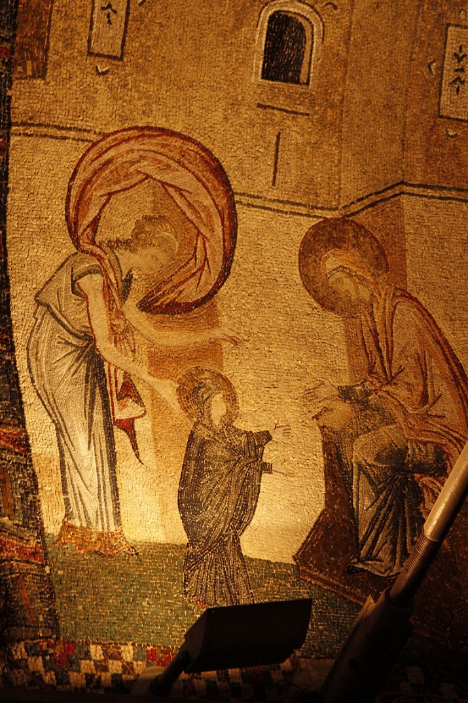
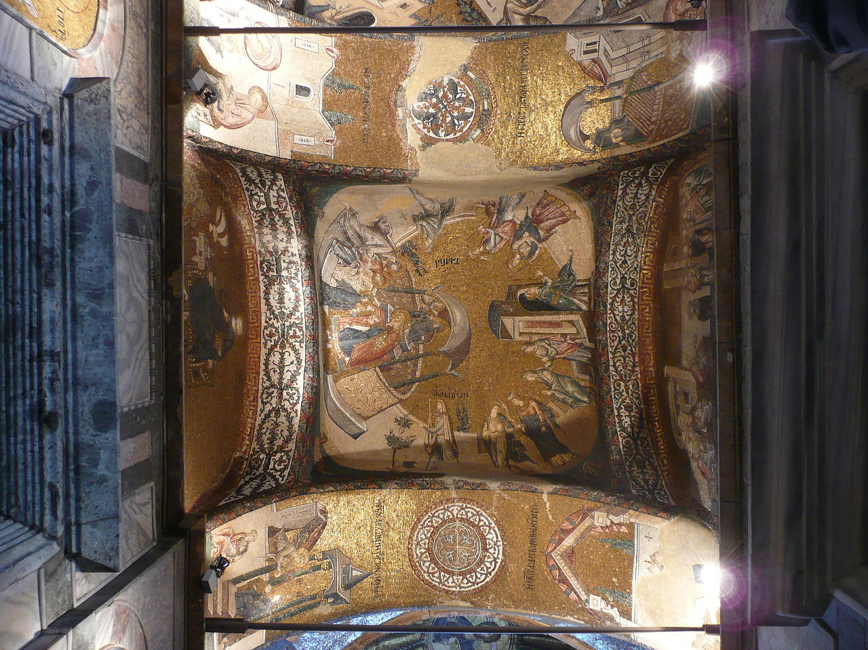

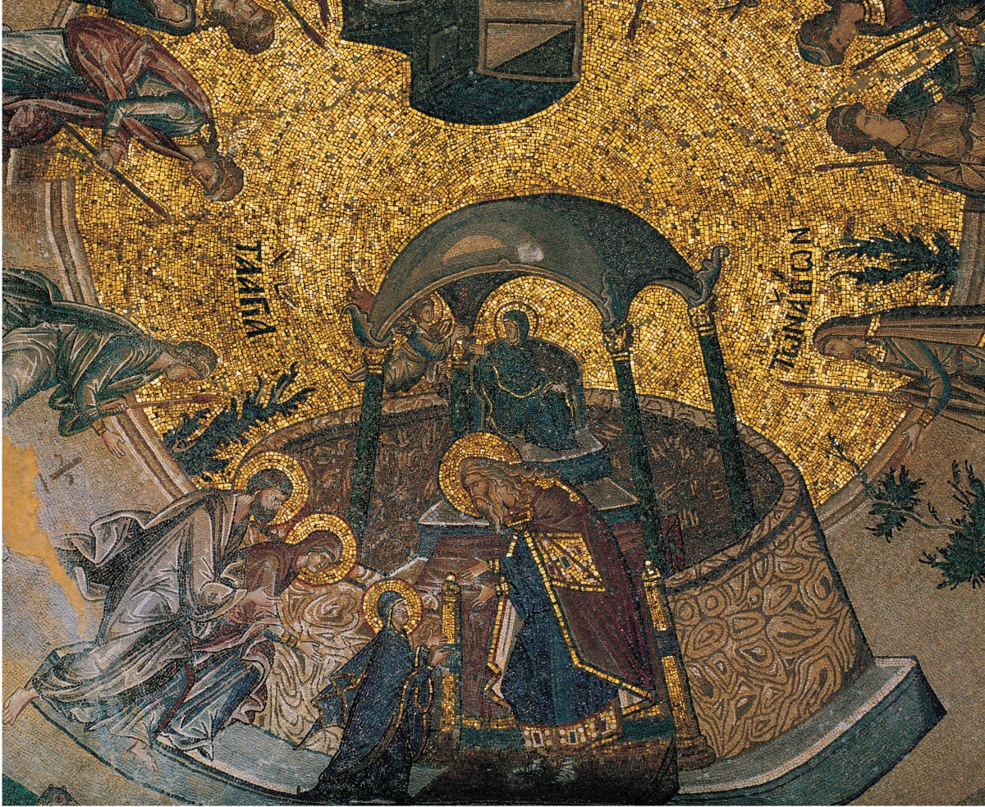

- Use of “Magnificat” in s3:26, but on Muhammad’s lips

  - As well as a “unifier”, Mary is used to challenge Christians to see Jesus truly as son of Mary and not as son of God AND to challenge Jews that Mary/Jesus are important

- “Qur’an was aware of oral traditions about biblical characters but not of the Bible itself”

  - Makes no distinctions between traditions and canon eg calls characters by nicknames – recognised but not “loudly pushed” the logic of this

- That said, could we be use surah 3 another way? Eg:
1: God be praised! Let us extol Him,
He sent His beloved, to rescue us all through his name!
Mary’s son, his name is Jesus,
God sent him to save us, from all of our guilt and our shame!

2: The angels said, O Mary! God has chosen you,
He’s purified and made you holy, He selected you.
Above all other women, in all the Worlds He made,
He’s chosen and preferred you, Mary, don’t forget this word.

3: Read Surah Alé-Imran, the 42nd verse,
Listen to its secret, brothers, pay heed to the words,
If the mother is so great, then how much greater is the son!
The son of Mary’s name is Jesus, he’s God’s holy one.

4 A Slightly Thematic/Systematic Reading of Jesus in the Qur’an

- 275 references to Jesus according to www.quranbrowser.com/

- Surah 4:171: “O People of the Book! Do not exaggerate in your religion nor utter anything concerning God except the truth. The Messiah, Jesus son of Mary, was only a Messenger of God, and His Word, which He conveyed to Mary, and a spirit from Him. So believe in God and His Messengers, and say not ‘Three’ – Cease! (It is) better for you! God is only One God. Far is it removed from His transcendent majesty that He should have a son. His is all that is in the heavens and all that is in the earth. And God is sufficient as Defender.” (Pickthall, 2005).

  - What can we agree with? What should we disagree with?

- Qur’anic “Positives”:

- Prophet – Deuteronomy 18:15-22, 1 Kings 19:16, John 1:45, Acts 3:22-26, Hebrews 1:1f

- Priest – Exodus 28:40-41, Leviticus 21:10-12, Zechariah 3, Hebrews 3-10

- King – 1 Samuel 16:11-13, 2 Samuel 7:1-7, Psalm 2, Matthew 16v13-17, Acts 2

- Creative – Genesis 1, Psalm 33:6

- Powerful & accomplishes God’s purposes – Isaiah 55:10-11

- With God and distinctly divine – John 1

  - Jesus also:

          - Created life, healed the sick and raised the dead (Surah 5:110)

          - Came with clear revelation (Surah 43:63)

          - Is a sign and mercy (Surah 19:21, 21:91)

          - Is righteous (Surah 19:19 cf all others who have sinned: Adam (7:22-23), Abraham (26:82), Moses (28:15-16), David (38:24-25), Jonah (37:141-144), Muhammad (48:1-2))

          - Will come back for judgment (Surah 43:61 and 4:159)

- But negatives too!

  - Not a son

  - Not crucified (surah 4:157)

- “Islam represented a fourth theological/Christological position within the religious milieu of the seventh-century Middle East.”

  - Neither Nestorian, Chalcedonian or Monophysite; but Arian-ish plus docetic/gnostic on Jesus’ death

  - Again, Islam cannot seem to deal with a God who is both transcendent and immanent, who is absolute and present, who is the God of Isaiah 57:15 and John 1 – Islam doesn’t start with the revelation previously given and see “God from below” or “Jesus from below”

  - Emphasises physical link to Abraham eg surah 2:135

- So, read the Qur’an with a friend?

5 Some Resources for Further Study
Ahmed, Hasanuddin, Introducing the Quran – how to study and understand the Quran, New Delhi: Goodword Books Pvt. Lt, 2004.

Cook, Michael, The Koran a very short introduction, Oxford: OUP, 2000.

Ernst, Carl W, How to read the Qur’an, a new guide with select translations, Edinburgh: Edinburgh University Press, 2011.

Hinds, Jeremy, Qur’an Course, via CMS, from: http://www.word-of-life.org/category-s/113.htm

Lodahl, Michael, Claiming Abraham: reading the Bible and the Qur’an side by side, Brazos Press, 2010.

Neuwirth, Sinai, Marx ed., The Qurʾan in Context, Historical and Literary Investigations into the Qurʾanic Milieu, Leiden: Brill, 2009. Particularly:

Michael Marx, “Glimpses of Mariology in the Qur’an: from hagiography to theology via religious-political debate”, pp.533-564

Angelika Neuwirth, “The house of Abraham and the House of Amram: genealogy, patriarchal authority, and exegetical professionalism”, pp.499-532

Gabriel Said Reynolds, “Reading the Qur’an As Homily: the case of Sarah’s laughter” pp.585-592

Reynolds, Gabriel Said, Qur’an in its Historical Context, Oxford: Routledge, 2008

Gabriel Gabriel Said, The Emergence of Islam: Classical Traditions in Contemporary Perspective, Minneapolis: Fortress Press, 2012

White, James R, What Every Christian Needs to Know about the Qur’an, Grand Rapids: Bethany House, 2013

Quoted in Ernst, How to read the Qur’an, 23.
"The Seven Sleepers of Ephesus ", Folio from a Falnama (Book of Omens) c1550s Iran. No pages. Cited 27th February 2023. Online: "The Seven Sleepers of Ephesus", Folio from a Falnama (Book of Omens) | The Metropolitan Museum of Art (metmuseum.org)
No pages. Cited 27th February 2023. Online: watchers04_09.jpg (299×294) (bibliotecapleyades.net) / https://www.bibliotecapleyades.net/imagenes_aliens/watchers04_09.jpg.
Ibn Ishaq, The Life of Muhammad, transl by Alfred Guillaume (Karachi: OUP 2001), pp133-141. Ibn Ishaq 85-151AH/704-770AD, ed by Hisham d212 or 218AH/831 or 837AD, and in Tabari 224-310AH/843/929AD. This seems equivalent to 2-4 generations post-Apostolic. More useful information at Ibn Ishaq - Wikipedia / https://en.wikipedia.org/wiki/Ibn_Ishaq
More “apocryphal” information here: Golden Gate (Jerusalem) - Wikipedia / https://en.wikipedia.org/wiki/Golden_Gate_(Jerusalem)
More information about him here: Ephrem the Syrian - Wikipedia / https://en.wikipedia.org/wiki/Ephrem_the_Syrian
Michael Marx, ‘Glimpses of Mariology in the Qur’an: from hagiography to theology via religious-political debate’, on p542 and 544 from the liturgy of the Syriac Orthodox Church, date unclear in Angelika Neuwirth, Nicolai Sinai, Michael Marx ed., The Qurʾan in Context, Historical and Literary Investigations into the Qurʾanic Milieu (Leiden: Brill, 2009). See Chora_1200_983.jpg (1200×983) (cornucopia.net) / Chora_1200_983.jpg (1200×983) (cornucopia.net) for some great art on this theme.
Marx, ‘Glimpses of Mariology’, p553.
Michael Lodahl, Claiming Abraham: reading the Bible and the Qur’an side by side, (Brazos Press, 2010), p142.
By Gryffindor - Own work, Public Domain, https://commons.wikimedia.org/w/index.php?curid=2551539
By © José Luiz Bernardes Ribeiro /, CC BY-SA 3.0, https://commons.wikimedia.org/w/index.php?curid=16832738
Gabriel Said Reynolds, The Emergence of Islam: Classical Traditions in Contemporary Perspective, (Minneapolis: Fortress Press, 2012), pp126-133.
Reynolds, Emergence of Islam, p128.
Lodahl, Claiming Abraham, p109.
Song written by Wycliffe Bible Translators in Sylhet, Bangladesh.
Reynolds, Emergence of Islam, pp165-6 and Lodahl, Claiming Abraham, pp158-159.
See Richard Bauckham, Jesus and the God of Israel (Milton Keynes: Paternoster, 2008) for much more detail.

