LECTURE 2: A VERY SHORT INTRODUCTION TO MUHAMMAD AND HISTORIES

- What do these verses from the Qur’an tell us about Muhammad:

3:144

12:2-3

17:105

18:110

29:50

33:40

46:9

- Yet, “To be clear, the use of the Qur’an as a primary source for our understanding of the historical Muhammad will not yield a comprehensive story”

1 “What do you think of Muhammad?”
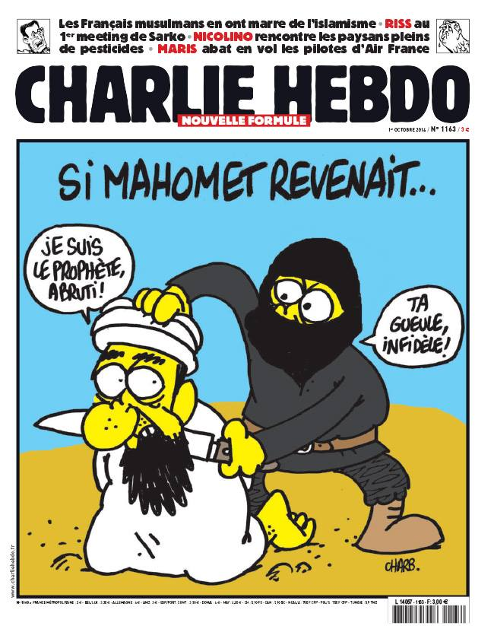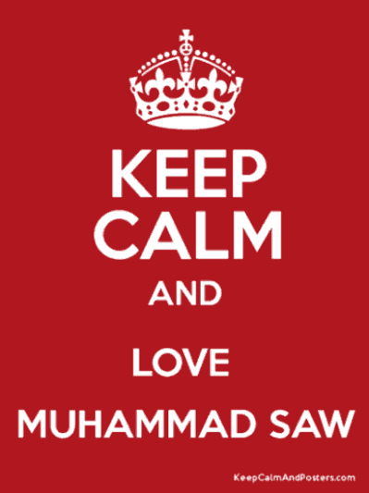
A cask by losing centre-piece or cant "And most certainly, thou (O
Was never shattered so, as I saw one rent Muhammad) are of most sublime
from the chin to where one breaketh wind. and exalted character." (Surah 68:4)
Between his legs were hanging down his entrails;
His heart was visible, and the dismal sack How can you not love the Prophet
That maketh excrement of what is eaten. Muhammad? at www.youtube.com/
While I was all absorbed in seeing him, watch?v=XTVWfbD90sg
He looked at me, and opened with his hands
His bosom, saying: "See now how I rend me Who is the most influential man in
How mutilated, see, is Mahomet; history? Michael Hart The 100: A
In front of me doth Ali weeping go, Ranking of the Most Influential
Cleft in the face from forelock unto chin; Persons in History
And all the others whom thou here beholdest,
Disseminators of scandal and of schism See www.amaana.org/ismailim.html
While living were, and therefore are cleft thus. and “Muhammad the Greatest” by
A devil is behind here, who doth cleave us Ahmed Deedat at
Thus cruelly, unto the falchion's edge www.islamhouse.com/144901
Putting again each one of all this ream, /en/en/books/Muhammad_the
When we have gone around the doleful road; _Greatest and www.youtube.com
By reason that our wounds are closed again /watch?v=Klx9lzzGjcw
Ere any one in front of him repass

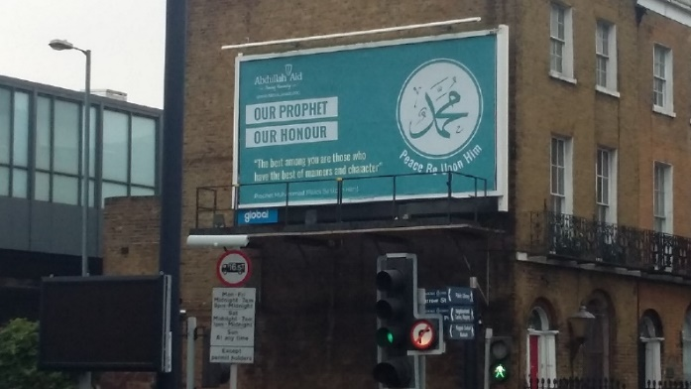
- Lamartine “Histoire de la Turquie” (Paris, 1854): “…Philosopher, orator, apostle, legislator, warrior, conqueror of ideas, restorer of rational dogmas, of a cult without images, the founder of twenty terrestrial empires and one spiritual empire, that is Muhammad. As regards all standards by which human greatness may be measured, we may ask, is there any greater man than he?”

  - So, we can see that cartoons might be problematic

- And, remember shame and honour dynamic

  - But, blasphemous?

2 Mohammedans?

2a) Not at All!
- “According to Islamic belief, the Prophet Muhammad was the last Messenger of God. He, like all of God's prophets and messengers – such as Noah, Abraham, Moses and Jesus – was only a human being. Christians came to the mistaken assumption that Muslims worship Muhammad by formulating an incorrect analogy – they worship Jesus so they assumed Muslims worship Muhammad. This is one of the reasons that they called Muslims by the incorrect name "Mohammedans" for so many years!...”

- Hadith recorded by Sahih Bukhari, Volume 4, Book 55, Number 654: “Narrated 'Umar: I heard the Prophet saying, "Do not exaggerate in praising me as the Christians praised the son of Mary, for I am only a Slave. So, call me the Slave of Allah and His Apostle."

- At Muhammad’s death, Abu Bakr said (in Bukhari, Volume 2, Books 23, Number 333, see http://ahadith.co.uk/chapter.php?cid=72): “Whoever amongst you worshipped Muhammad? Muhammad is dead. But whoever worshipped Allah? Allah is alive and will never die. Allah said ‘Muhammad is no more than a messenger, many were the messengers that passed away before him...[from surah 3:144]”

- Surah 18:110: “Say: ‘I am but a man like yourselves, (but) the inspiration has come to me, that your Allah is one Allah: whoever expects to meet his Lord, let him work righteousness, and, in the worship of his Lord, admit no one as partner.’”

2b) But Maybe…
- Hard not to idolise the greatest man ever, eg Al-Busiri’s The Poem of the Cloak or The Blessed Burdah (at Qaseedah Burdah Shareef with English Translation - Minhaj-ul-Quran):

‘I have neglected the path of the one who brought black nights
To life by praying, until even his feet swelled with distress.
To quell his hunger he tightened his midriff
By strapping stones to his soft sides and strong ribs.

Lofty mountains, to entice him, draped themselves in gold,
But he showed them a towering soul, perfectly content, without desire.
The extremity of his needs only confirmed his freedom from desire –
Need never overshadows Virtue that is firmly rooted.

How could the need of such a man be answered by the world,
When without him this world would never have come into being!
Muhammad, lord of both worlds, lord of both species,
Lord of both assemblages – Arabs and all others.

Our prophet, commander of right, forbidder of wrong –
No soul kept his word more justly, whether “Yes” or “No”.
He is the beloved whose intercession is hoped for
As arms against a host of relentless calamities.

He called on God. Whoever clings to him
Clings to a rope that will neither unravel nor break.
His form and character surpassed even the previous prophets,
And none have approached him in knowledge or nobility.

Incomparable, his beauty has no peer –
The essence of beauty itself is in his nature.
Leave aside what the Christians have claimed for their prophet –
Then praise him as you like, but do so wisely.

Ascribe to his essence what you wish of honour,
Attribute to his exalted status what you will of greatness!
Truly, the Messenger of God’s bounty
Cannot be overstated by two lips and a tongue.

If a miracle could equal his stature in magnitude,
The mere mention of his name would revive decaying bones.
He is like the sun, small to the eye when seen from afar,
But when glimpsed close up, it dazzles and overwhelms.

The extent of what we know of him is this: He is a man,
And yet, without exception, he is the best of God’s creation.
All of the signs brought by the noble prophets before him
Came to them through his light alone.

He is the bounteous sun and they her orbiting planets –
She reveals their lights for humanity in the darkness of night –
Until finally his light dawned on the horizon,
And his radiant guidance suffused the world and brought life to countless civilisation.

What excellence lies in the birth of a prophet adorned with such character!
Beauty itself shines forth from his smiling face!...’

    - “If God ”

    - “He is ”

          - And visit the holy hair…Don't miss Mega Mawlid & Ziyara to the Holy Hair of Prophet(s) in Michigan! - YouTube / https://www.youtube.com/watch?v=yg0FtGr_mBI

- And, if the shahada concerns God and Muhammad

  - And, if Muhammad is the difference between truth and lies: Musaylima (“the liar” and a false prophet) offered to share power with Muhammad, believing in Al-Rahman/The Merciful, final judgement, daily prayer and regular fasting

- And, if salat includes “Greetings to you, O Prophet, the mercy and blessings of Allah”

- And, if Muhammad is buried in the mosque in Medina which is a place of pilgrimage (?hajj) – then three of five pillars include Muhammad in some way)

- And, if “The Prophet is closer to the believers than their selves, and his wives are (as) their mothers…” (Surah 33:6)

- And, if Muslim people are to emulate Muhammad (eg Surah 33:21) and Point 3a last week

- And, if hadith says things like…

  - None will have faith until he loves Muhammad more than his family and all humanity

  - Obeying Muhammad = obeying Allah and v.v. Same for Muslim chief and Muhammad.

- And, if Muhammad is an intercessor on the Last Day: “O Muhammad raise your head and speak for you will be listened to; and ask for you will be granted your request: and intercede, for you intercession will be accepted.” I will say, “O Lord, allow me to intercede for whoever said La ilaha ill-Allah. Then Allah will say, “By My Power and My Majesty, and by Supremacy, and by My Greatness, I will take out of Hell whoever said La ilaha ill-Allah.”.

- Then maybe…

3 A Bit About History and Arabia before Muhammad

- Some brief words on history

  - History is about recognising difference, context and process

  - Different perspectives are helpful eg Carl Trueman’s, Histories and their Fallacies, Tamim Ansary’s Destiny Disrupted: A History of the World Through Islamic Eyes, Peter Frankopan’s Silk Roads: A New History of the World, and listen to all The Rest is History podcasts with Tom Holland and Dominic Sandbrook not least #60 “Muhammad” and #265 “Saudi Arabia: The Mystery of the Kaaba”

  - “Sources relating to early Islamic period are complex and pose serious problems for interpretation”

  - Can Muslim people cope with the historical-critical method?

    - Why has there been so little archaeological work in Mecca, Medina and Hijaz

- Arabia: caught between Christian Byzantines in NW, Zoroastrian Persians in NE, Yemeni Kingdom in south and Axumite Kingdom of Ethiopia in SW (see Donner’s article on VLE)

  - A time of war, plague, economic problems, some trade

    - Although trade is controversial when thinking about Mecca – was it on a trade route at all?
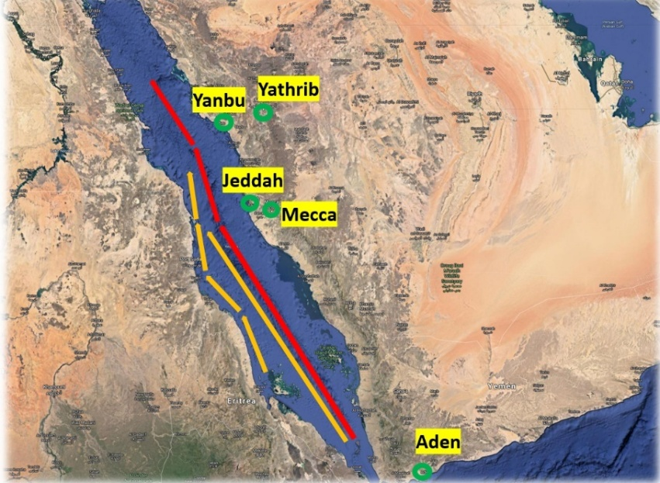

- Christianity seen as foreign, divided and persecuting, if known about at all

- “The age of ignorance” (Jahiliya, Surah 5:50)

4 Some Known Knowns (probably)

4a) Contested Histories
- Internal critique: “Muhammad is bad”

- External critique: “Muhammad is a bad idea”

- 100+ years between Muhammad and first biographies, eg Ibn Ishaq (704-767) but comes to us through ibn Hisham who edited it (d.833) and was partially reconstructed by a German scholar in 19th C and translated by a French scholar in 20th C…:
c.570 Born in Mecca (father died before birth)
c.576 Mother (Amina) died (looked after by grandfather and then uncle)
595 Married Khadijah
610 Received first revelations
615 Persecution, some followers fled to Abyssinia
619 Death of Khadija and Abu Talib
622 Migrated (hijra) from Mecca to Medina
624-7 Battles with Meccans (Badr, Uhud and Ahzab)
628 Treaty with Meccans (Hudaibiya)
629 Muhammad and 10,000 Muslims return to Mecca
632 Died in Medina

- Can we trust the Islamic sources?

  - Of course!

  - No! They’re Sunni!

  - No, because seem too far away and not corroborated, eg no mention of Muhammad in contemporary sources, but his name becomes widespread under Abd al-Malik ibn Marwan (ruled 685-705, built Dome of the Rock)

    - Some coins in the British Museum:
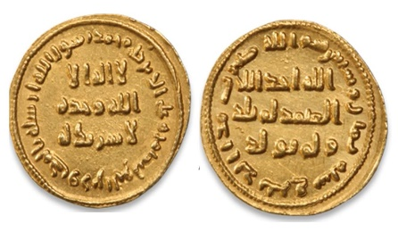
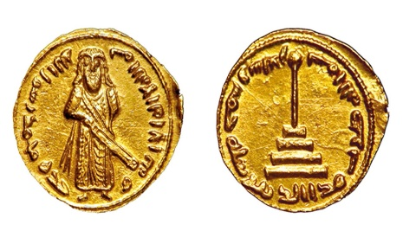

- Shoemaker, The Death of a Prophet:

  - Doctrina Iacobi nuper baptizati (634-40AD) suggests that a prophet (?Muhammad) led Arab armies into Palestine

  - Secrets of Rabbi Shimon b Yohai (mid 8thC, but based on earlier sources) sees fulfilment of Numbers 24:21 and Isaiah 21:6-7 in a prophet of the Ishmaelites (Muhammad?) liberating Jews from Byzantium

  - Life of Patriarch Benjamin (before 717AD) talks about Muhammad leading a nation which conquered Damascus and Syria

  - Very hard to work with the sira tradition as it appears “to reflect the convictions and concerns of the communities and individuals who produced them” (more in Hadith lecture)

  - Qur’an is “profoundly ahistorical” in contrast to gospels or Acts (more in Qur’an lectures)

  - From 5th C have reports of Arabs adopting laws and customs of Jews

  - Syriac writers of 7thC frequently identify Muhammad/MHMD as king of Arabs not a prophet

    - Does Abd Malik add “Muhammad is his prophet” to shahada in the Dome of Rock to make this a distinctly Islamic form of monotheism?

      - Which doesn’t seep into land or consciousness for some time? Eg John of Damacus seeing Muslim people as followers of “heresy of Ishmaelites”

  - Qibla towards Jerusalem suggest Palestine as focus, with entry into land similar to Moses or return from exile

    - Although latest research suggests Petra is the direction of some qibla (see Jay Smith’s PPT)

  - 3 major differences between Islamic and non-Islamic sources: chronology of Muhammad’s death, the sustained inclusion of Jews within early community, and the religious importance of Jerusalem and Palestine for Muhammad and earliest followers.

- See pp143-197 in Accad and Andrews, eds., The Religious Other: initial conquests noted anecdotally, “little significant religio-theological reaction or reflection” (p143), interpretation through apocalyptic lens (p147), explanation of terms like Saracen (p149-154), considered a version of monotheism (p155)

- See also Harald Suermann, “Early Islam in the Light of Christian and Jewish Sources”, in Angelika Neuwirth et al The Qur’an in Context, pp135-148 – a prophet came with the conquering Saracens, who fast and pray (and oppress, massacre and commit prostitution), and do not eat carrion or drink wine, knowing the history of Moses and following the God of Abraham

- Jay Smith pushes this: the prophetic Muhammad is a creation of the 9th C Abbassid rulers, based on an Arab leader (MHMD) in the 7th C who helped to liberate Arabs and forge an Arab identity – due to no coins or rock inscriptions referring to Muhammad (but to MHMD) or first 4 caliphs, early qiblas pointing to Petra, Qur’anic Arabic being northern, and no mention of Muhammad in the Qur’an

  - Could it just be the evolution of an ideology and rule – see Stefan Heidemann, “The Evolving Representation of the Early Islamic Empire and its Religion on Coin Imagery”, in Angelika Neuwirth et al The Qur’an in Context, pp149-195, with Muhammad’s name appearing on coins raising him “to a position almost as sacred as the divine revelation itself”

  - Rock inscriptions from the 660s whose calendar begins in 622, are led by a “commander of the believers”, whose language is Arabic and have phrases similar to the Qur’an

    - So…

4b) An “Orthodox” History of Change
- “A great future lies for your nephew”

- Preacher of heaven and hell in Mecca

- Persecuted by those threatened by his message – some flee to Abyssinia (more later) and remainers boycotted and eventually Muhammad flees to Medina in 622/1

- Preacher of whole of life in Medina (see Surahs 2, 4, 9 and 47) – Charter of Medina / Covenant with the Jews

  - “In the following decade (622-632 C.E.), Muhammad and his growing band of followers were to engage in a series of battles to defend Islam against the military aggression of their adversaries…”

- Is there a change? If so, why?

  - Power corrupts?

    - Converts awarded booty as well as salvation, with pyramid system from caliph upwards receiving decreasing %, but all did receive something.

  - Reliance on human wisdom (and rejection of the cross, see Luke 9 in later lecture)?

    - See also Peter Cottrell, Muhammad – the man who transformed Arabia, (Acorn Press, 2011): shalom preached is not the shalom practiced

4c) So, is Muhammad Blood-Thirsty and Womanising?
- Fight those who fight you until there is no more oppression (Surah 2:190-193), fighting is prescribed (2:216), fight unbelievers (9:5, 29, 123), fight those who opposed Muhammad (9:13-14), rewarded if killed (3:157, 169, 195), rewarded if win (8:41)

- Killed poetic caricaturer, http://www.answering-islam.org/Muhammad/Enemies/asma.html

- Involved in 20-100 skirmishes/battles, eg https://en.wikipedia.org/wiki/List_of_expeditions_of_Muhammad;

  - Slay unbelievers to further Islam in surah 9 Al-Tawbah aya 5 cf Bukhari Bk 2, ch 14, No 24

  - Digging trenches and chopping heads off in ibn Ishaq p461-465

  - Carried on by companions and afterwards into Syria and across to Spain, eg al Waqidi, The Islamic Conquest of Syria and Morera, The Myth of Andalusian Paradise (more in Lecture 8)

  - Comparable to taking of Canaan and killing of opposition?

- Surah 33:50 for > 4 wives

  - An uncontrollable paedophile?

    - “Uncontrollable desires” critiqued from the beginning

    - Underage marriage/sex not an issue until 1905

  - “Those for whom their right hands possess”

    - Surahs 4:24, 23:6 and 70:30 imply sex with women captured in war

    - Hadith affirms this for 4:24, after Muhammad appeared reluctant to have sex with women captured from their polytheist husbands (in Sahih Muslim 8.3432, Bukhari 5.59.459 and Sunan Abu Daud 11.2150)

  - Comparable to Patriarchs, David and Solomon?

5 But Still Perfect?

- Muhammad as the perfect man (al-insan al-kamil) and pure/holy

  - But had to be cleansed of sins before night journey according to ibn Ishaq and Bukhari

- Made only human errors eg discrimination of blind man in s80:1-12 (but not as a prophet)

  - But many references to sin and need for forgiveness in the hadith

- More here: The Sinlessness of the Prophets: The Isma Doctrine (answering-islam.org) / https://www.answering-islam.org/Gilchrist/Vol1/7b.html

6 Some Resources for Further Study
Guillame, Alfred. The Life of Muhammad – a translation of Ibn Ishaq’s Sirat Rasul Allah. Karachi: OUP, 2001.

Holland, Tom. In the Shadow of the Sword – The Battle for Global Empire and the End of the Ancient World. London: Abacus, 2013.

Jenkins, Philip, The Lost History of Christianity. New York: Harper Collins, 2008

Power, Bernie, Understanding Jesus and Muhammad: what the ancient texts say about them (Moreland, Victoria: Acorn Press 2016).

Shoemaker, Stephen J, The Death of a Prophet: The End of Muhammad’s Life and the Beginnings of Islam (University of Pennsylvania Press, 2015).

Silverstein, Adam. Islamic history: a very short introduction. Oxford: OUP, 2010.

Martin Accad, “The Quest for the Historical Muhammad”, in Accad and Andrews, eds, The Religious Other, 289.
From http://cdn.frontpagemag.com/wp-content/uploads/2015/01/charlie-hebdo-no1163-011014.jpg, accessed 23rd February 2015. See also Jay Smith at Speakers’ Corner the Sunday after the killings, https://www.youtube.com/watch?v=3jrsap2t870.
From http://www.keepcalmandposters.com/poster/keep-calm-and-love-muhammad-saw
Dante, Inferno section of Divine Comedy, Canto 28, verses 30-31.
“Lamartine’s Views on the Prophet Muhammad Peace be Upon Him”. No pages. Cited 30 September 2013. Online: http://www.scribd.com/doc/2607490/LAMARTINES-VIEWS-on-Prophet-Muhammad-Peace-be-upon-him.
See my photo outside Limehouse DLR from summer 2021, and also Nathan Lovell, “Marching for Allah: how should we respond to the Muslim protests?” Briefing Issue 403, January-February 2013.
“Do Muslims Worship Muhammad”. From http://www.islamicweb.com/begin/myth3.htm, accessed 11th September 2017.
Gabriel Said Reynolds, The Emergence of Islam: Classical Traditions in Contemporary Perspective (Minneapolis: Fortress, 2012), pp. 63-64 based on ibn Ishaq.
Dr Muhammad Muhsin Khan, Summarised Al-Bukhari Arabic-English (Saudi Arabia: Dar-Us-Salam Publications, 1996), Bk2, ch7, #14&15 (1:13, 14 OB).
Khan, Summarised Al-Bukhari, Bk53, ch50, #1270 (4:204 OB).
Khan, Summarised Al-Bukhari, Bk88, ch6, #2229 (9:601 OB).
See also Samuel Green, “A Common Word” 17th January 2012, The Briefing, at http://matthiasmedia.com/briefing/2012/01/a-common-word/ and a talk I gave: https://eustonchurch.s3-eu-west-1.amazonaws.com/RS_2020_1_29+Evangelistic+Event.mp3, both accessed 5th February 2024.
John Tosh, The Pursuit of History, (Oxford: Routledge, 2015, 6th edition), 8-11.
Peter Frankopan, Silk Roads: A New History of the World, (London: Bloomsbury, 2016), 73.
Daniel Brown, “What we don’t know about Islamic origins” in Accad and Andrews, The Religious Other, 175.
Frankopan, Silk Roads, 63, 75-77.
Jay Smith’s PPT on VLE, Slide 24 of “Historical Critique of Islam’s Origins – UK Edition 2022”, presentation.
For a more critical approach to this history see Tom Holland, In the Shadow of the Sword, (Abacus, 2013) or Stephen J Shoemaker, The Death of a Prophet: The End of Muhammad’s Life and the Beginnings of Islam (University of Pennsylvania Press, 2015).
See also Jay Smith’s PPT in VLE, Slide 36 and The British Museum, London :: Islamic Coins (washington.edu) / https://depts.washington.edu/silkroad/museums/bm/bmislamiccoins.html
Shoemaker, Death of a Prophet, 23.
Shoemaker, Death of a Prophet, 28.
Shoemaker, Death of a Prophet, 39.
Shoemaker, Death of a Prophet, 101, based on work by Patricia Crone.
Shoemaker, Death of a Prophet, 119, based on work by Fred Donner.
Shoemaker, Death of a Prophet, 203-4.
Shoemaker, Death of a Prophet, 211.
Shoemaker, Death of a Prophet, 212-3.
Shoemaker, Death of a Prophet, 223. However, some suggest qibla actually towards Petra.
Shoemaker, Death of a Prophet, 277, based on work by Michael Cook.
See especially slides 73-86, 93-94, 96-97 and 110-112 Jay Smith PPT “Quest – Islam in the 7th Century”
Stefan Heidemann, 170.
Daniel Brown, “What we don’t know about Islamic origins” in Accad and Andrews, The Religious Other, 176, quoting Robert Hoyland’s work. See also p183-4 and 188.
A Guillame, The Life of Muhammad – a translation of Ibn Ishaq’s Sirat Rasul Allah (Karachi: OUP, 2001), 79-81.
A Rashied Omar, “Islam and Violence Revisited”, Journal of Ecumenical Studies, vol52, no.1, Winter 2017, 70.
Guillame, Muhammad, 231-233.
Omar, “Islam and Violence Revisited”, 71.
Frankopan, Silk Roads, 77.
Jonathan Brown, Misquoting Muhammad: the challenge and choices of interpreting the Prophet’s legacy, (London: One World, 2014), 144-148
Nabeel Qureshi, Seeking Allah, Finding Jesus, (Grand Rapids: Zondervan, 2014), 242-245.
Bernie Power, Understanding Jesus and Muhammad: what the ancient texts say about them (Moreland, Victoria: Acorn Press 2016), 57, quoting two Muslim authors.
Power, Understanding Jesus and Muhammad, 58.
Power, Understanding Jesus and Muhammad, 62

