LECTURE 1: A VERY SHORT INTRODUCTION TO A VERY SHORT INTRODUCTION

1 Clearing the Ground a Bit

- Why are we interested in Islam?

  - Here's something from a friend about Muslim people engaging in mission and how he then got involved in mission to Muslim people:
The Pastor's Heart with Dominic Steele: Islam, Christianity and the World Cup in Qatar - with Sam Green on Apple Podcasts / https://podcasts.apple.com/gb/podcast/the-pastors-heart-with-dominic-steele/id1338733715?i=1000589780594

- How do you feel about all this?

500 CHURCHES TURNED INTO MOSQUES IN A CITY
Some numbers:
1961 50k
1971 226k
1981 550k
1991 950k
2001 1.6m (2.7%)
2011 2.8m (4.4%)
2021 4m (6%)
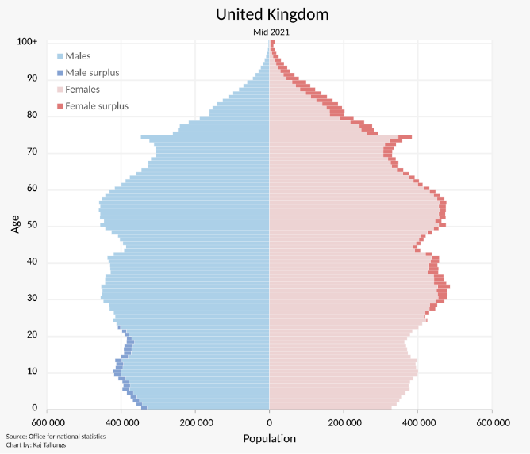
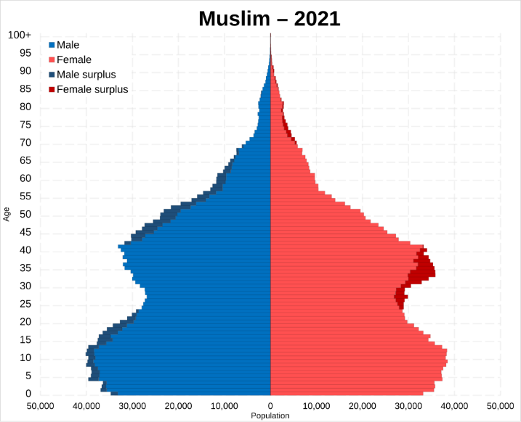
Born in the UK – %
Arrived before 1971 – %
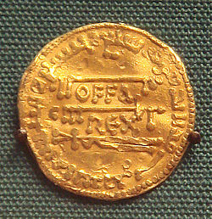
Arrived 1971 to 1990 – %
Arrived 1991 to 2010 – %
Arrived 2011 to 2021 – %

- Colonialism, economics, conversions, and long-term contact

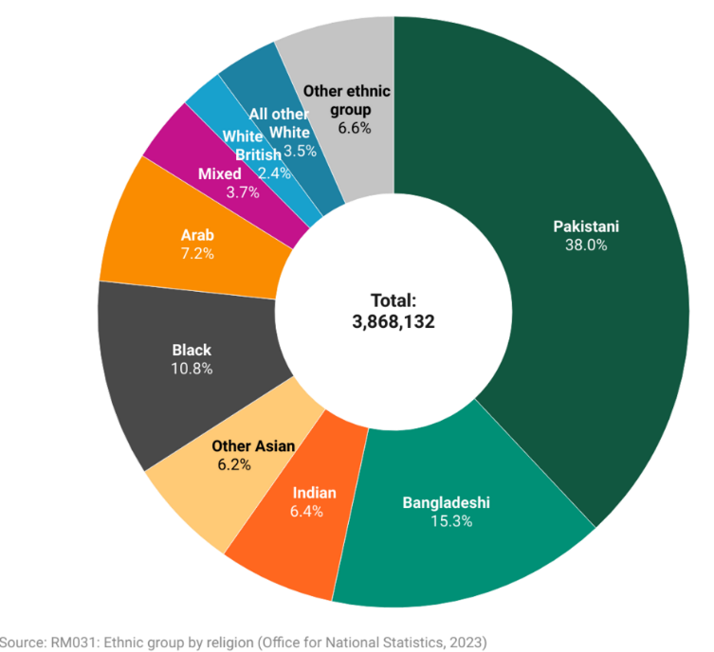
Walking through a crowded place,
Judgmental stares
Apparent on every face,
For actions taken in my name
You think that I am in disgrace,
You refused my hand
You ignore my embrace
What did I do to deserve this hate?

I wear a headscarf,
My dad has a beard,
You mock me and say I’m weird,
I fast,
I pray,
I volunteer,
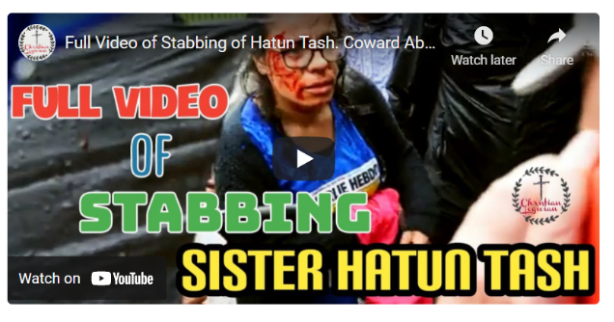
Yet still I am unwelcome here,
Practising my faith in constant fear.

Terrorists deface Islam as they
Ravage and ruin the common man,
This is not my faith and not Islam,
Don’t assume it is, we’re about salaam,
Don’t hold me accountable for the insane,
As all around you’ll see the same.
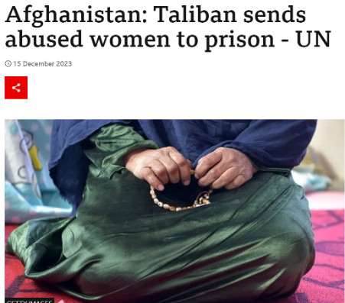
“We are here to stay, we are here to plant Islam in this part of the world and we must utilize everything in our power to make the word of Allah supreme”
Ismail R Faruqi, The Path of Da’Wah in the West (London: UK Islamic Mission, 1986), p19

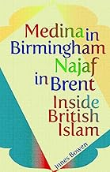
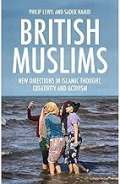
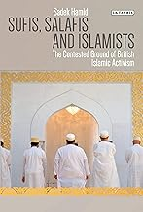
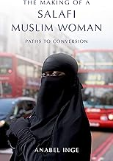
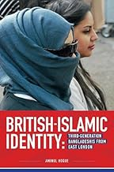
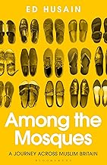
https://mcb.org.uk/2021-census-as-uk-population-grows-so-do-british-muslim-communities/ (29th November 2022, accessed 22nd January 2024)
- Some responses:

- Maybe f and l ???

- Replace with f and l : God is and Muslim people are

- Dangers of generalising, but:

  - All people are made in the image of God (Genesis 1-2) – worthy of respect

  - All people are fallen (Genesis 3) and are suppressors of truth (Romans 1) – need to receive the Gospel

    - This true for Islam too – perhaps more so eg “Abrahamic”, “Ishmaelites”

    - Added twist of being post-Christian, eg “a Muslim view of Jesus”

    - Answers the “are they saved?” question

    - Answers the “why do they do good things?”, “what do we do with the true things in their religion?” and “are they close to God?” questions

2 Islam by the Numbers 5, 6 and 4

- Dangers of over-generalising and over-specialising

  - “Islam should be whatever your friend says it is.” – we must deal with how Muslim people shape Islam in their context

- Many islams – find out from a Muslim friend, why not ask:

- What does it mean for you to be a Muslim?

- Do you go to mosque, watch Islamic TV or have a favourite preacher?

- Would you call yourself a perfect Muslim? Do you think a person can be?

- When you die, will you go to paradise?

- Do you think people understand the Qur’an properly?

- Have you ever learned about Christianity? What do you know?

- Have you ever learned about the Bible? What do you know? Have you read it?

- Can I explain what the Bible is to you?

- A reminder from God’s Word – “All Scripture is breathed out by God and profitable for teaching, for reproof, for correction, and for training in righteousness, that the man of God may be competent, equipped for every good work.” (2 Timothy 3:16)
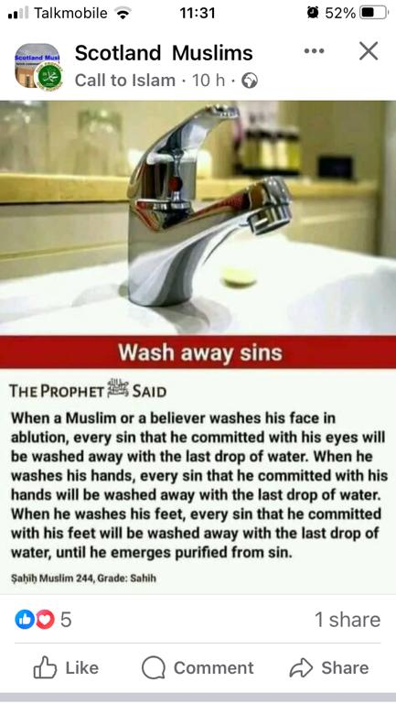

2a) 5 Pillars
- Shahadah/profession (surah 2:255, 48:29, 64:8)

- Salat/prayer (surah 11:114)

- Saum/fasting (surah 2:183-185)

- Zakat/almsgiving (surah 2:177)
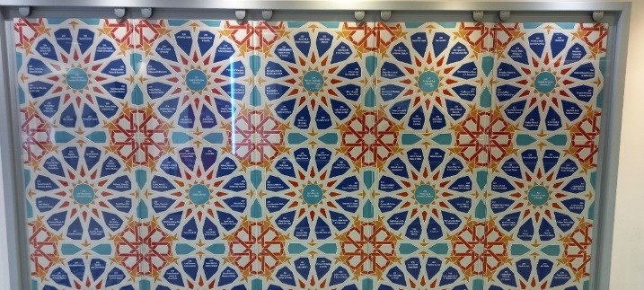

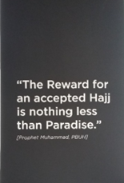

- Hajj/pilgrimage (surah 22:26-33)

2b) 6 Beliefs
- The oneness of Allah

- Allah’s angels
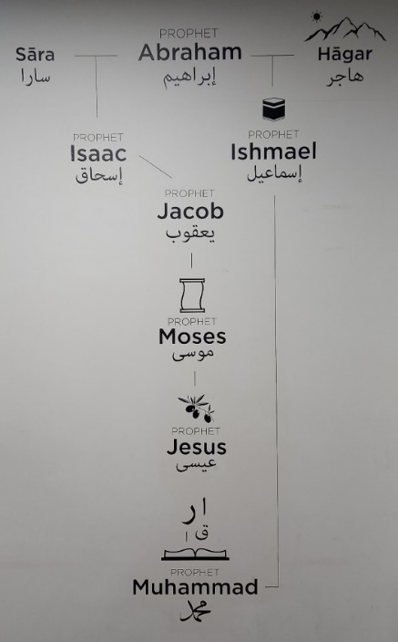

- Allah’s messengers/prophets

- Allah’s revealed books (eg Torah, Zabur, Injil & Qur’an)

- The day of resurrection (physical and to judgement)

- Allah’s divine decree/sovereignty (surmised from surah 2:177, 285, hadith)

2c) 6+ for Shias
- Dissimulation, analogy, Mahdi (Messiah) and ayatollahs (speakers for God)

- ?jihad

2d) Have a Think…
- Don’t forget 2 Timothy 3:16 and pick a pillar or a belief. How might you start a conversation about it with a Muslim person, and go from there to Jesus? What Bible story could you tell?

- And, what objections to the Christian faith might/does a Muslim person have?

2e) 4 Big Objections
- P & C objections

- Surah 4:171 –

- Surah 4:171 cf 5:73, 75, 116 –

- Surah 4:157 –

- The Bible has been C !

  - BUT, Qur’an says it confirms previous Scriptures (surah 4:163-165, 5:44-47 cf 3:3-4, 21:7 & 48, 10:94) AND, Allah doesn’t allow his word to be changed (surah 6:34, 6:115, 10:65, 15:9)

  - SO, previous Scriptures not corrupted, but misquoted (surah 2:75, 4:46 cf 5:13 & 41)

    - Creates the Islamic Dilemma, eg David Wood Wants To Change Apologetics: The Islamic Dilemma / https://www.youtube.com/watch?v=rbqLsvMY38c

3 What Else is Important in a Muslim Person’s Life

3a) Hadith/Muhammad
- Muslim people emulate Muhammad (eg surah 33:21)

  - Imam Malik ibn Anas’ “Al-Muwatta”, Book 46, No. 461.3: The Messenger of Allah, may Allah bless him and grant him peace, said, ‘I have left two matters with you. As long as you hold to them, you will not go the wrong way. They are the Book of Allah and the Sunnah of His Prophet.’” (cf Sahih Bukhari Vol 9, Book 92, No. 387) – from 163-203AH…(cf 610, 622, 632AD and Tom Holland’s In the Shadow of the Sword)

    - So, challenge the Qur’an and Muhammad?

- Hadith and Muhammad become the interpretive key to the Qur’an and to all of life – hadith provides more detail, more fear and more comfort

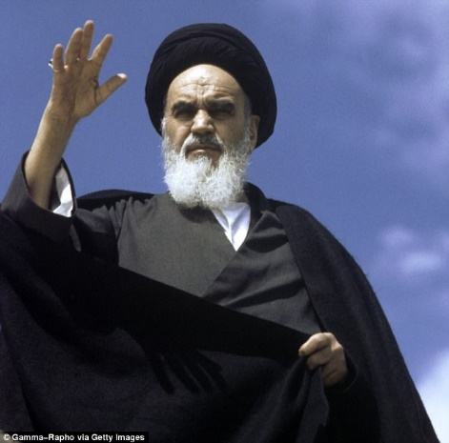
- May lead to “fundamentalist Islam” (Salafi), eg Surah 3:104, 110, 7:157, 9:71: enjoin what is right, forbid what is evil

- As Muhammad said, "Whoever amongst you sees an evil, he must change it with his hand; if he is unable to do so, then with his tongue; and if he is unable to do so, then with his heart; and that is the weakest form of Faith". (Sahih Muslim).

- Ahmad ibn Taymiyya (from Harran in Mesopotamia, 1268-1328): “The duty of commanding good and forbidding the evil cannot be completely discharged without power and authority.”

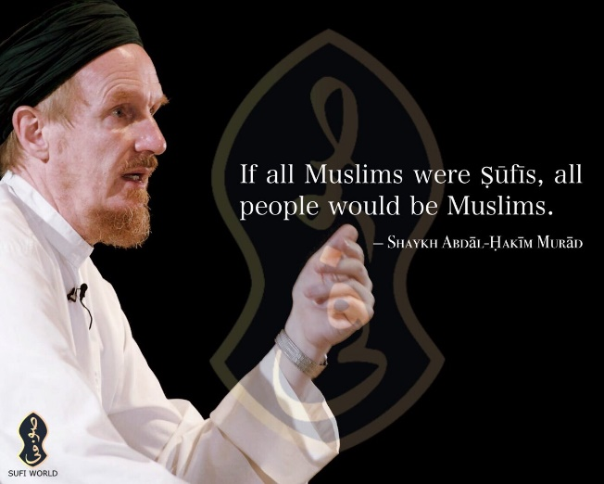
- May lead to more “woolly Islam” (Sufi), with Muhammad as perfect man and mediator

  - Inner dimension

  - Closeness to God is possible

  - Need a guide and discipline

3b) Spiritual Forces
- Recognition of “included middle” of beings between us and (a distant) God, eg jinn

- May lead to “folk Islam”, eg coriander demons and charms (more in Bill Musk Unseen Face of Islam, (London: Monarch, 2003)

3c) Group Orientation
- Maybe biggest part of world view: “I belong therefore I am” vs “I am a self-standing person”

  - Or is it?

- Behaviour reflects on whole group – therefore shame and honour important, and can lead to a lack of privacy and “thinking for self”

  - Timothy C Tennent in Theology in the Context of World Christianity, p98: “Missionaries who have worked in shame-based cultures frequently observe that the reason most Muslims, Hindus, and Buddhists resist becoming Christians is not primarily because of specific theological objections to the Christian message. More often, there are powerful social and cultural forces that serve as the primary barrier to Christian conversion. People in a shame-based culture are more acutely aware of the surrounding opinions of the group and are constrained from taking individual action in isolation from the larger group. Our frame of reference is apologetically focused on convincing individual Muslims of the truth of Christianity. However, the major barrier is actually not theological or doctrinal, but social, cultural and relational. This larger issue is often ignored completely.”

4 Some Useful Things for Further Study
Bannister, Andy, Do Muslims and Christians Worship the Same God? IVP, 2021.

Bell, Steve, and Chapman, Colin, eds. Between Naivety and Hostility – Uncovering the best Christian responses to Islam in Britain. Milton Keynes: Authentic, 2011.

Goldsmith, Martin. Beyond Beards and Burkhas. Nottingham: IVP, 2009

Ibrahim, I. A. A Brief Illustrated Guide to Understanding Islam. Houston: Darussalam, 1997.

Qureshi, Nabeel. Seeking Allah, Finding Jesus. Zondervan, 2016

Pratt, Zane. “Islam 101”, Theology Refresh: Podcast for Christian Leaders, Islam 101 | Desiring God

Scott, Robert. Dear Abdullah. Nottingham: IVP, 2011.

https://www.cmcsoxford.org.uk/our-events?mc_cid=00b393d1ed&mc_eid=a9f7ebdc7b

Critical Muslim / https://www.criticalmuslim.io/

Islam and Christian–Muslim Relations: Vol 33, No 4 (Current issue) (tandfonline.com) / https://www.tandfonline.com/toc/cicm20/current

5 Some Preparation / Homework

For Lecture 2 on Muhammad and Histories
- What do these verses from the Qur’an tell us about Muhammad:

3:144

12:2-3

17:105

18:110

29:50

33:40

46:9

For Lecture 3 on Response to Muhammad
      - How do you respond to your friend who asks “what do you think of Muhammad?”

        - What would you say? Why?

        - How might you “subvert and fulfil” Muhammad?

- Read Senem Ekener, “Muhammad Case Study”, in Accad and Andrews, eds., The Religious Other, 284-5 and answer the questions on p285.

- Do you need to change your answer to “what do you think of Muhammad”?

For Lecture 5 on Qur’an Pt2
- Read surah 18. Can you discern a structure to the surah? If so, what might it be? What are its themes? Do they make much sense?

- Read surahs 3:33-64 & 19:1-40. Who are these about? What is similar/different to the Bible’s account? How might Ezekiel 43:1-12 & Luke 1-2 provide something of a background to this (if you think a little laterally!)?

For Lecture 6 Response to Qur’an
      - How do you respond to your friend who asks “what do you think of the Qur’an?”?

        - What would you say? Why?

        - How might you “subvert and fulfil” the Qur’an?

- Read Hanane, “Qur’an Case Study”, in Accad and Andrews, eds., The Religious Other, p213-4 and answer the questions on p214-5. Then read “Testimony 2” p215-7.

- What would you now say in response to someone who asks you “what do you think of the Qur’an?

For Lecture 7 on Some Modern Missionary Approaches
- Read the Camel Method Presentation PPT. What did you think? Good, bad, useable? Is it the best thing since Paul in the Areopagus? Is it twisting someone else’s scripture? Would you use this method?

- Read the Camel Method Critique from 9 Marks. Do you agree with them?

From File:Shah Jahan Mosque TQ0159 214.jpg - Wikimedia Commons
Offa king of Mercia 757 793 gold dinar copy of dinar of the Abassid Caliphate 774 - Offa's imitation dinar - Wikipedia
Yasmin’s Poem, 30 Days of Prayer Guide 2017, 38
Esther O’Reilly, An interview with Hatun Tash, the Christian preacher stabbed at Speakers' Corner | The Spectator, accessed 6th September 2021.
BBC News, Afghanistan: Taliban sends abused women to prison - UN - BBC News, 15th December 2023, accessed 29th January 2024.
Warrick Farah, “Adaptive Missiological Engagement with Islamic Contexts”, The Religious Other, p113, italics in original.
From Samuel Green, Jars of Clay: Evangelizing Muslims, The Briefing, Issue 382/3, July-August 2010.
Quoted by Patrick Sookhdeo, Understanding Islamic Theology (McLean, VA: Isaac Publishing, 2013), 14.
Quoted in Lesslie Newbiggin, Lamin Sanneh and Jenny Taylor, Faith and Power: Christianity and Islam in ‘Secular’ Britain (Wipf and Stock, 2005), 62.

