**How to Write an Essay**

NB: Everything that follows states an ideal and presumes circumstances conducive to writing an essay. The Lord may not give you such circumstances. You may be out of sorts, your wife may give birth, your child may get chickenpox, there may be a serious pastoral crisis, an unexpected funeral to plan, &c.

Do your best, as serving the Lord, within the circumstances that he has given you. Essays matter, but there are more important things than essays.

**Two reasons why we ask you to write essays:**

* Writing forces you to commit. We can all happily meander through reading, but when someone says ‘Now put down on paper what you think’ it forces you to face important theological questions and to work out a position on them.
* Essay writing skills are relevant to sermon preparation skills. They are not the same but there is a significant and fruitful overlap. They are a subset of sermon preparing skills:
  + Working out what you think about a theological question.
  + Processing reading material and turning it into an argument.
  + Presenting your position clearly.
  + Presenting your position persuasively.

Despite the overlap, remember that essays are definitely not sermons, for the benefit of both!

**Where you probably think you will go wrong:**

Missing key reading.

Making theological mistakes.

**Where you are actually most likely to go wrong:**

Answering the wrong question.

Writing a *partly* irrelevant answer.

Writing an answer that *could* be relevant but is not *evidently* so.

Writing a disorganised answer.

Writing a badly presented answer.

**The main stages of writing an essay:**

Identifying and understanding the question.

Finding the reading.

Reading and note-taking.

Planning the essay.

Writing the essay.

Reviewing the essay.

We take them in turn…

**Identifying and understanding the question:**

The question is a strict control on your essay. It is not a prompt or a trigger.

What exactly is it asking? What is it not asking? Be scholastic about it.

**Finding the reading:**

Have you been given a list?

Is the list in order?

Is the list intended to be comprehensive?

Finding more: use the footnotes and bibliographies in the given reading as leads – note the other major figures with whom your authors are interacting. Discerning use of the internet. Appropriate and inappropriate sources.

**Reading and note-taking:**

There are different types of reading with different goals.

For example, if you are set an essay on Book 1 of Augustine’s *Confessions*, you should read the whole work, but you should read Book 1 very slowly and carefully. Your notes will need to be a comprehensive summary of Book 1. Your notes on the rest of the work may be more superficial.

Distinguish:

Reading in order to give a detailed account of what this text says. This requires close, slow reading and detailed summary note-taking.

From:

Reading to harvest material for your own treatment of a topic. This might be a lot of material, or it might be just a few choice points or quotations.

It is like the difference between listening to someone you are counselling and asking someone for directions.

If you own a book, mark it, then type up what you have marked.

Your marking can and should include your own thoughts as you interact with what you read. This may be something as brief as a 🗶 to mark disagreement or a ✓to mark agreement, or a ? to mark uncertainty. Or it may be an actual sentence or two written along the margin noting why you think this is a good point, or what you think is wrong with it, or what it makes you need to think about. Some people use the inside covers for more notes, or even for creating their own index. When you type up your comments you will need to distinguish them from the author’s own points. I put my own responses inside [] in my notes and/or mark them with GW:.

Distinguish typing up *actual quotations* (which need to be clearly marked as such in your notes with ‘’ and a page reference) from typing up a summary of the point the author makes (which will be re-worded and page referenced but without ‘’). This is the point at which you do careful work to avoid accidental plagiarism, because when you later return to your notes you won’t know which is which unless you have explicitly and carefully made the distinction in them.

When should you use actual quotations? Sparingly, for example much more sparingly than I do in my lectures.

Reproduce actual quotations for one of three reasons:

1. If there is a disagreement about what an author says then you will need to quote from them carefully to prove your interpretation.
2. Quote because an author makes the point succinctly and you cannot do a better job of it. This is not that common – you can usually think of a more succinct way of putting something.
3. Quote because they put the point strikingly and beautifully – you feel that you want to pass on this quotation as a gift to you reader. This is a really good reason to quote.

At this level you will probably never need to quote long passages. Feel uneasy on line 3.

You should avoid too much quotation because it is lazy. It does not show that you have understood and can explain a point. It is therefore very hard for the marker to credit. He is in effect marking someone else’s work. In some cultures verbatim quoting of an elder is a way to honour him. This is not the case in your essay. The aim is not to communicate honour but to make your own case.

You should type up notes on everything you read into separate files, saved with the author and title as their name. I save like this: ‘Gaffin – Resn & Redn – Notes’. This allows me to distinguish this file from the text itself if I have it: ‘Gaffin – Resn & Redn – Text’. Save them all as distinct files. Make the first line of each document the full bibliographical reference for the source: Author, Title, Place, Publisher, Date (plus volume and page span if a journal article, editor and page span if a chapter within an edited book).

You may be tempted to put them all in one file as ‘Notes for essay X’, but don’t. Hopefully, the usefulness of the reading will not be limited to that essay, so you don’t want to have to remember which essay you read it for in order to find your notes on it.

Order your files into folders. I have a list of folders that looks a bit like this:

OT

NT

Early Church

Medieval

Reformation – C18th

Victorian to C21st

Ecclesiology

Ethics

Theology of Worship

Etc.

Under pressure for time you may find yourself wanting to type directly from the articles/books into your essay itself. This is very likely to end up costing rather than saving you time. The problem with it is that it cuts out the processing and planning stage, i.e. the stage at which you do your actual thinking about the material and ordering of it. You end up copying across lots of material into your essay file and it all ends up in a big mess that then you have to wrestle it all into some kind of coherent argument from in the midst of it. Even a 3000 word essay contains sufficient material that it will be very hard to untangle if you have just bashed it in without first digesting and ordering it.

**Planning the essay:**

This is the indispensable heart of the process.

When you have done all your reading, open up a new document, or even better print out all your notes and get a blank sheet of paper and a pencil. This will be your first draft of a plan.

Make sure your note files are all page numbered, either electronically or by hand.

Re-read the question and read over all your notes.

Having done this, you should have some idea of what you think the answer to the question is and what some of the major points you need to make are, at least enough to begin sketching.

If you can, write down a thesis statement: a single-sentence statement of your answer to the question.

Then just re-read your notes and pull out of them:

The points you want to make to support your answer.

Any objections to those points and your replies.

Other major arguments for the other side.

Your response to those arguments.

Relax about the order at this stage. Just pick something as you start reading your notes, one of the major arguments that has risen to the surface *as an answer to the question*, and make an abbreviated note of it.

For example, take the question: ‘Evaluate the arguments for the phrase ‘works of the law’ in Paul referring only to the visible, outwards identity markers of being a Jew.’

You disagree with the claim. You might begin with a simple point cited in its favour: ‘The term did include such markers’.

Then, I suggest using a loose mind-mapping method, branch off from that point to the evidence for it. For example: ‘P’s concern with circumcision’.

Then add a counter argument: ‘More than circumcision in Rom. 2’.

Read on in your notes. It may be that the next point to emerge is a totally different one, in which case start a new cluster.

As you map out like this, cross-reference from your plan to your notes. Mark the margin of the notes where you include something in your plan using a letter, starting afresh with A on each page. For example on the plan ‘Gaffin, 2B’ would be a reference to your notes on Gaffin, page 2, point marked B. This prevents you needing to copy all the info on to your plan. When you come to writing you will be able to follow your plan back to the notes.

Keep doing this until you have worked through all your notes.

This sketching is the stage at which you do your thinking. You are re-reading your notes, pondering what you have harvested, working out what you think about the points you are re-reading, formulating your arguments, the objections, and your replies.

You should now have a page or pages of messy scribblings but within them a series of distinct points emerging, each in the form of a central point with branches coming off it.

Each cluster will form the basis for a paragraph of the actual essay, or perhaps a few paragraphs.

Here is an example of one of my plans and pages of notes:

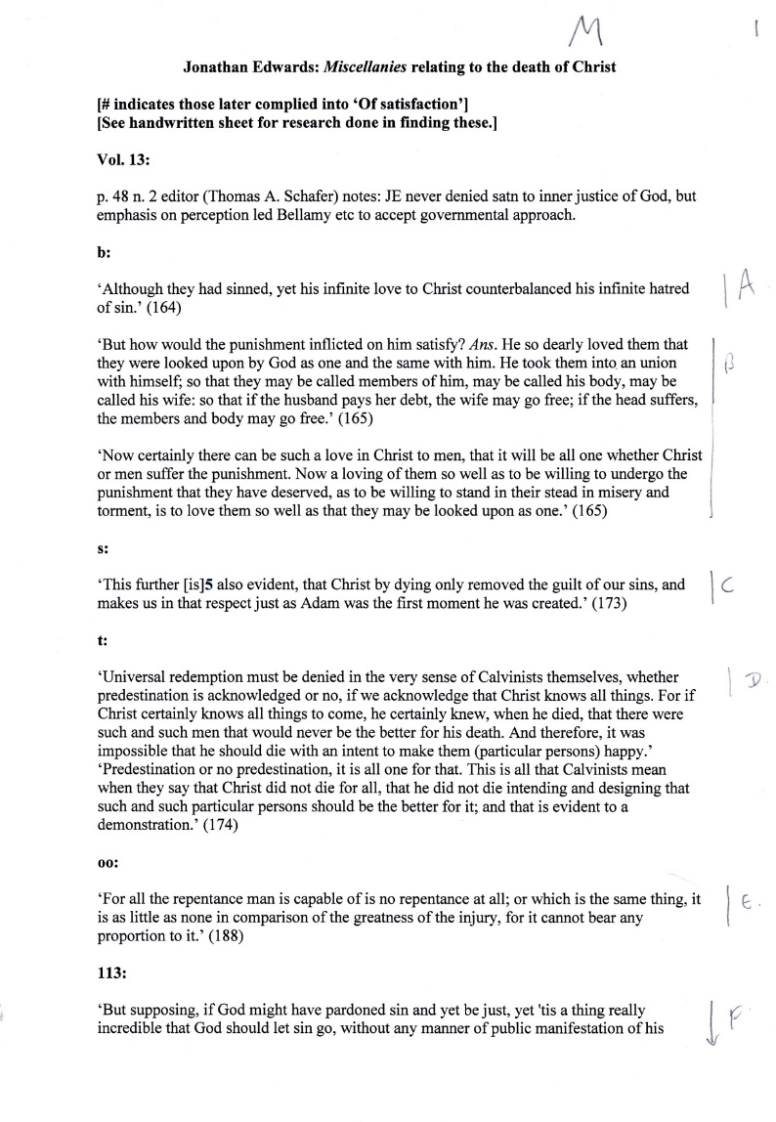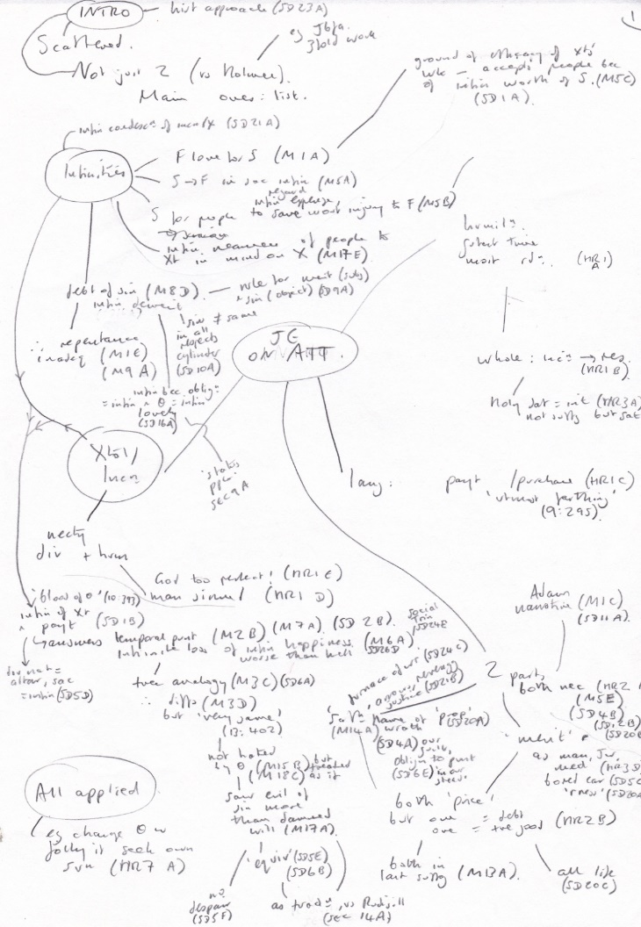

The next stage is to rework the material into a sequence, putting the distinct gathered points into a logical order. You can either do this by adding larger arrows and numbering, or by rewriting the whole thing more neatly. Here you are essentially sequencing what will be the paragraphs in your essay.

You should group the points into those that you are supporting and those that you are objecting to, either setting out your case first and then the possible objections, or your opponent’s case and your responses first followed by your own positive arguments and replies to objections.

**Writing the essay:**

When you have done the hard work of planning then the actual writing will be much easier. You are choosing your words, which is really important, but the hard thinking and organising has all been done in the planning stage. You are now just working through your plan step by step, following the arrows and the numbering and putting it into full sentences.

You may find you change your mind about something or have significant further ideas at this stage. I often find that the actual process of writing is very fruitful for new thinking. In which case, revisit and adapt the plan.

NB this secret of good essay writing: Presume your reader is a sceptical idiot. Sceptical: he is jaded by years of marking. He fully expects you to fail to answer the question you have been asked. His red pen is poised ready to strike out entire pages of material and to write down the side ‘IRRELEVANT’ in exasperated capital letters. An idiot: presume that he struggles to follow an argument and to see its relevance and that you need to be extra, super-clear on where you are in your case, why you are here, and where you are going. At the start of each paragraph you should pause to reorientate the reader by making explicit reference back to the question and stating what you are doing in this paragraph, as why you are turning to do it now. An inelegant but effective way of doing this (and much better than being irrelevant, or failing to show relevance – better inelegant than irrelevant; better to be slightly off the dress code than at the wrong party!) is to cite the very words of the question at the beginning of every major section.

For example: ‘Having considered the arguments in favour of ‘works of the law’ referring only to identity markers of being a Jew, I turn now to show from Romans 2 why such a limited definition cannot account for Paul’s actual use of the phrase’. See what this does: it takes stock, it states the point about to be made, and it refers to the question proving relevance.

You should write the introduction and conclusion *after* writing the body of the essay.

The introduction should succinctly state your thesis and outline the argument of the paragraphs that follow, probably one sentence per paragraph. You are not playing Poker – do not keep your cards close to your chest. By the end of the introduction your reader should know exactly what you think, and in headline form, why you think it. Think of the 3am test for a sermon.

Unless you exercise great self-restraint, a number of you will use your first sentence to tell your marker that you are going to answer the question that has been set. Question: ‘Evaluate the arguments for the phrase ‘works of the law’ in Paul referring only to the visible, outwards identity markers of being a Jew.’

Pointless opening sentence: ‘In this essay I will examine whether or not ‘works’ of the law’ in Paul refers only the outward markers of being Jewish’. What a pointless statement! If someone asks you for directions to the station you don’t reply by saying ‘I will now give you directions to the station’. Open with your answer, not with saying that you will answer the question. If they are ambiguous then you can open by defining the terms of the question, but never by just saying you will answer what has been asked.

Your conclusion is then a summary of what you have said, plus it should open some windows to wider vistas.

**Reviewing the essay:**

It is difficult, probably impossible, to see mistakes in your own essay when you have just written it. Even typos become invisible, because you remember what you meant to type and your eyes see that, rather than what is actually on the page.

You need some distance. At the start of term when you have the assignment dates you should put a ‘first draft’ date in your diary maybe five days before the essay is due and work your scheduling back from there. This will allow you to set it aside for 48 hours, then re-read it and be horrified by what you find!

If English is your second language and you are not fluent, you should ask a native speaker to review and annotate your text, allowing you to see and make their changes and to learn from them.

**Referencing:**

The Handbook gives a minimum requirement (author, title, date, and page reference), but it would be good to adopt a full system now. You should definitely do this if you are thinking of taking the PRTS ThM. The dominant system in the theological world (and the one required for the ThM) is Chicago/Turabian. There is a quick guide here: <https://www.chicagomanualofstyle.org/turabian/turabian-notes-and-bibliography-citation-quick-guide.html>. If you are contemplating the ThM, you should also start using software like Zotero or Endnote that will automatically produce the footnotes and bibliography for you; you just enter the book details once into the library software and it does the rest every time you cite it. The sooner you start this the more time it will save you.